**LAB EXPERIMENT – 10**

**Nessus Essentials for Vulnerability Scanning**

**LAB PRACTICE:**

**Which company created Nessus?**

Nessus was created by Tenable, Inc. Tenable is a cybersecurity company that provides various security products and services.

**Under Scan Templates in Nessus, there is a scan for what type of Ransomware?**

Nessus does not specifically have a predefined scan template for a particular type of ransomware. Scan templates in Nessus are generally designed to identify vulnerabilities and security issues in systems rather than specific malware types.

**When creating a new Plugin Rule, what 4 fields do you need to enter?**

When creating a new Plugin Rule in Nessus, you typically need to enter the following four fields:

Name: A descriptive name for the rule.

Rule: The rule itself, specifying the conditions that trigger the rule.

Action: The action to be taken when the rule is triggered (e.g., alert, log, block).

Severity: The severity level assigned to the rule.

**Is there a scan template specifically designed for mobile devices?**

Yes, Nessus has scan templates that are specifically designed for mobile devices. These templates are tailored to assess the security of mobile operating systems and applications. Mobile device scan templates typically include checks for vulnerabilities and misconfigurations relevant to platforms such as Android and iOS.

**Vulnerabilities by Host**

**Advance Dynamic Scan**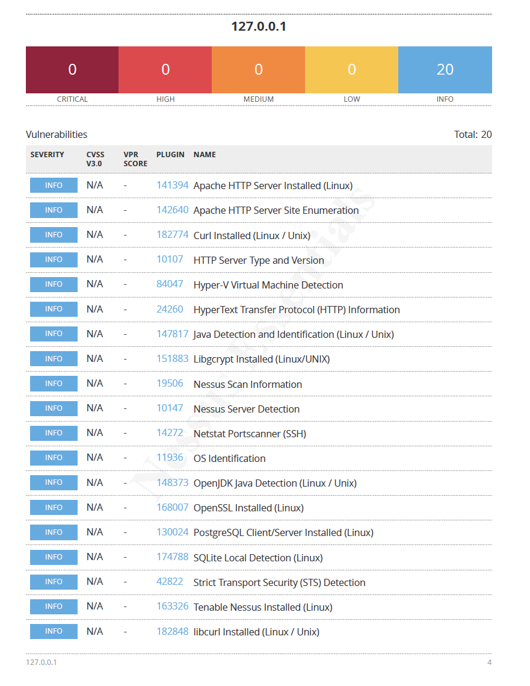

**Vulnerabilities by Host**

**Basic Network Scan**

